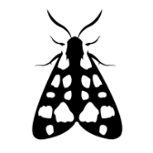
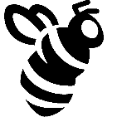
Pollinator Scavenger Hunt

- Bumble Bee
- Butterfly
- Hummingbird
- Blooming Tree
- Budding Flower
- Blooming Flower

https://www.pollinatorpartnership.ca

